I worked alone

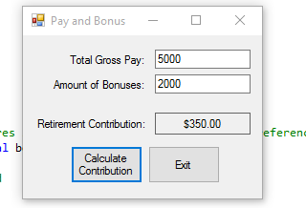

using System;

using System.Collections.Generic;

using System.ComponentModel;

using System.Data;

using System.Drawing;

using System.Linq;

using System.Text;

using System.Windows.Forms;

namespace Pay_and_Bonus

{

public partial class Form1 : Form

{

//constat field for the contribution rate

private const decimal CONTRIB_RATE = 0.05m;

public Form1()

{

InitializeComponent();

}

//input valid method converts the user input and stores it in the arguments (passed by the reference. If conversion is successful method returns true. otherwise returns false

private bool InputIsValid(ref decimal pay, ref decimal bonus)

{

//flag variable to indicate whetere input is good

bool inputGood = false;

//try converting inputs to decimal

if (decimal.TryParse(grossPayTextBox.Text, out pay))

{

if(decimal.TryParse(bonusTextBox.Text, out bonus))

{

//both imputs are good

inputGood = true;

}

else

{

//errir nessage for bonus

MessageBox.Show("Bonus amount is invalid");

}

}

else

{

//error message for gross pay

MessageBox.Show("Gross pay is invalid");

}

//return result

return inputGood;

}

private void calculateButton_Click(object sender, EventArgs e)

{

//variables for gross, bonus and contribuitlns

decimal grossPay = 0m, bonus = 0m, contributions = 0m;

if (InputIsValid(ref grossPay, ref bonus))

{

//calc the contribution amount

contributions = (grossPay + bonus) * CONTRIB_RATE;

//display contribution

contributionLabel.Text = contributions.ToString("c");

}

}

private void exitButton_Click(object sender, EventArgs e)

{

//close form

this.Close();

}

}

}